EXPERIMENT 6

AIM: Working with Docker Compose File to Control Multiple Containers

Steps to Complete:
Creating compose files
- Create a directory named nginx in your root.
mkdir nginx
- Switch to that directory and create a file named docker-compose.yaml
cd nginx
vi docker-compose.yml
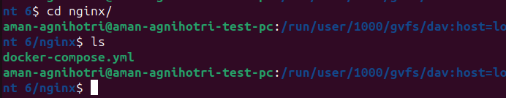
- Use docker-compose version 2 to create docker-compose.yaml file.
Create a service named "databases". Use image named "mysql"
Map container 3306 port to host machine 3306 port.
Add environment variables named "MYSQL_ROOT_PASSWORD", "MYSQL_DATABASE", "MYSQL_USER" and "MYSQL_PASSWORD" along with corresponding values for all.
cat evs.env
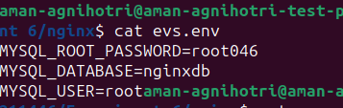
Add another service named "web"
Use image "nginx"
cat docker-compose.yml
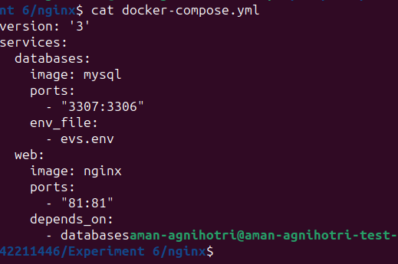
Running images using docker-compose
- Save docker-compose.yaml file and do docker-compose up.
docker-compose up -d
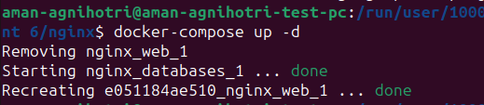

- Verify nginx service is up and is accessible on machine.

curl localhost:80
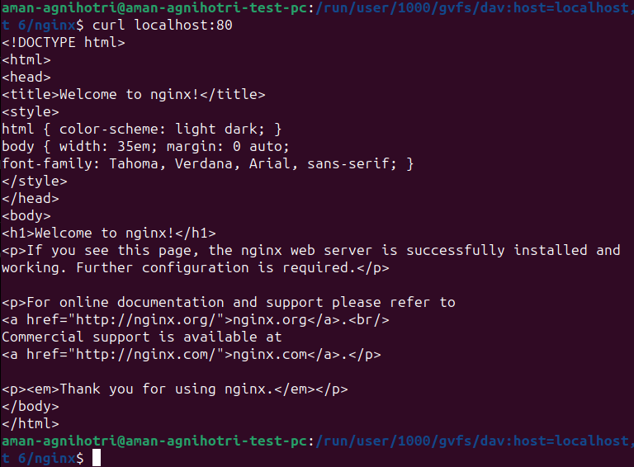
Stop and remove your docker container using docker-compose.
docker-compose down
